Farmer climbs high to escape crocodiles (adapted from www.bbc.co.uk)

An Australian farmer described how he spent seven days up a tree far from his home to escape crocodiles.
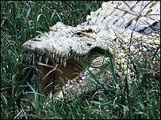
David George said two crocodiles stared at him every night

David George, 53, said that he had no choice. He went into an area in Australia where there are lots of crocodiles, and he could not escape on foot.
He only had two meat sandwiches to eat, and crocodiles moved under his tree each night until the rescue.
His problems began when he fell off his horse in the desert.
He was hurt and dizzy, but he climbed on his horse and hoped to get home. But the horse went the wrong way and soon he saw that he was in an area with many crocodiles.
I knew the safest thing was to stay and wait
David George
"I couldn't go back home, it was too far and too dangerous, so I went to the nearest high ground and stayed there. I hoped that people could find me."
'Red eyes'
Mr George, manager of the Silver Plains Farm near Coen in north Queensland's, said two crocodiles stayed at the bottom of the tree every night and stared at him.
"I saw red eyes below me and I was very scared”, he said. Mr George decided it was safer to stay in the tree.
Mr George ate his sandwiches in three days, but he had water in the day. He knew people wanted to find him because he saw helicopters above the tree.
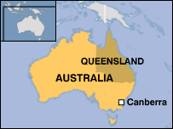
Then they came. They gave him a chocolate bar, and he said “it was fantastic."

Now answer these questions:

- How long did the farmer spend in the tree?

- Why did he climb the tree?

- Why couldn’t he get down?

- Why was he in this dangerous area?

- Why didn’t he leave and go home?

- Where is Mr George from?

- How did he feel after four days in the tree?

- What was his first meal after his rescue?

Now think of a different way to say these things:

Example:

- He could not escape on foot

It was impossible to escape on foot

- Two crocodiles stared at him

- I was very scared

- It was safer to stay in the tree

Now think of four questions you can ask this man:

Example:

How did you feel when you arrived home and saw your family again?

